**Name**: Samya Sunibir Das

**ID**: 1911563642

**Course and Section**: CSE332.3

**Submission Date**: 18th November 2020

**Lab 2 Table and Discussion**

1. Complete the truth table of the 4-bit arithmetic unit from the manual

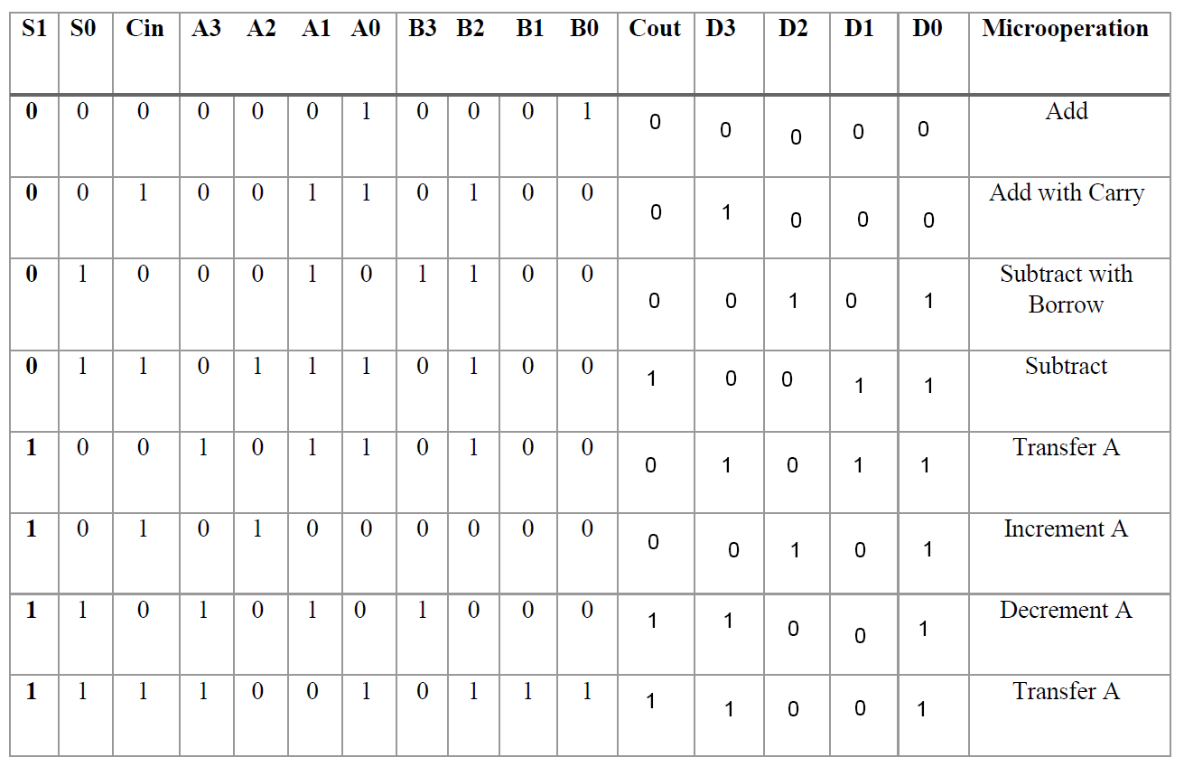

1. Discussion about the topics covered in Lab 2

In the second lab class, we were demonstrated how to design 2-bit arithmetic units in Logisim and we were informed about the various operations that are happening inside the circuit, for example: add, subtract (with 2’s complements), transfer, increment and decrement. Our lab task for this week was to implement a 4-bit arithmetic unit from what we learnt in Logisim.